Lab-Level 2

1 Display information for System Activity, Hardware and System Information.
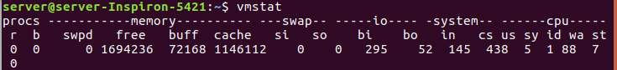
2 Get Information About Active / Inactive Memory Pages.
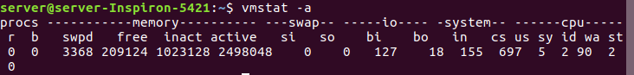
3 Find Out The Top 10 Memory Consuming Process (Implement using commands).

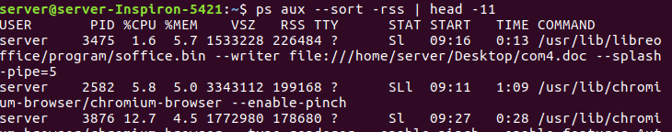
4 Display activities for each available processor.

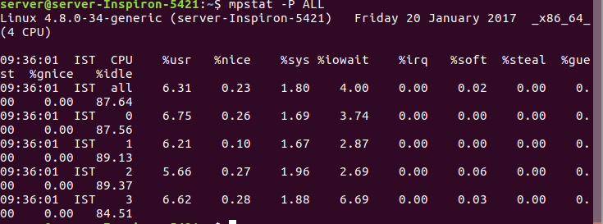
5 Display process memory usage. Also check for particular pid.

6 How to prevent ssh login? Implement, explain & how it works.
To disable root login, open the main ssh configuration file /etc/ssh/sshd_config with your choice of editor.
# vi /etc/ssh/sshd_config
Search for the following line in the file.
#PermitRootLogin no
Remove the ‘#‘ from the beginning of the line. Make the line look like similar to this.
PermitRootLogin no
Next, we need to restart the SSH daemon service.
# /etc/init.d/sshd restart

Shell Script Exercise
1 How to write shell script that will add two numbers, which are supplied as command line argument, and if these two numbers are not given show error and its usage.

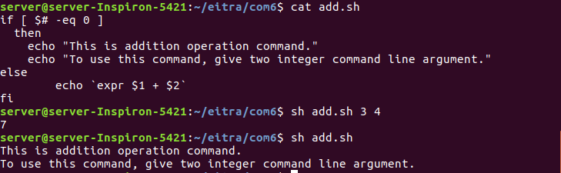
2 Write Script to find out biggest number from given three numbers. Numbers are supplies as command line argument. Print error if sufficient arguments are not supplied.
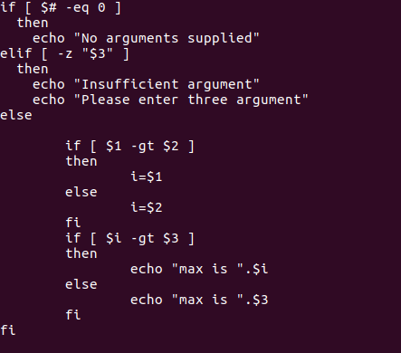

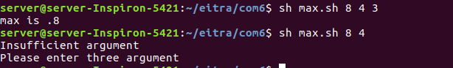

3 Write a simple shell script that takes any number of arguments on the command line, and prints the arguments with “Hello ” in front.
e.g. If the name of the script is “hello”, then you should be able to run it like this:
$ hello Nick Urbanik
Hello Nick Urbanik
$ hello Edmund
Hello Edmund
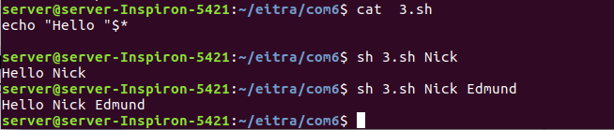
4 Write script to print numbers as 5,4,3,2,1 using while loop.
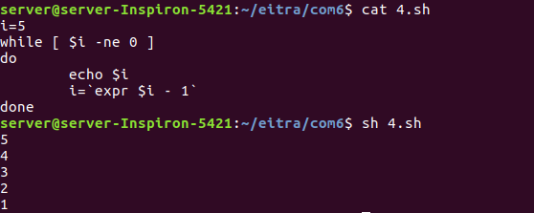

5 Write a simple shell script that takes two numbers as parameters and uses a while loop to print all the numbers from the first to the second inclusive, each number separated only by a space from the previous number.
e.g. If the script is called “jot”, then
$ jot 2 8
2 3 4 5 6 7 8

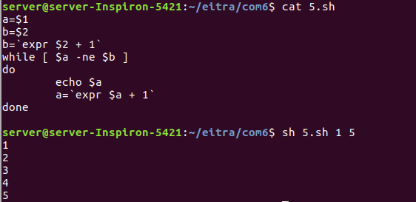

6 Write Script, using case statement to perform basic math operation as follows
+ addition
- subtraction
x multiplication
/ division
The name of script must be 'q4' which works as follows
$ ./q4 20 / 3, Also check for sufficient command line arguments
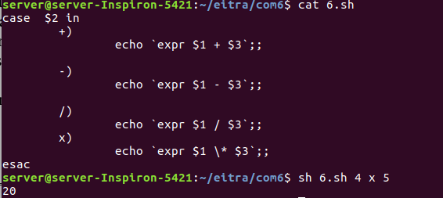

7 Write Script to see current date, time, username, and current directory
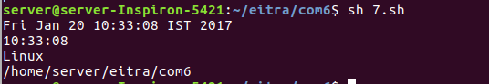

8 Write a script which displays “Good morning”, “Good afternoon” or “Good evening”, on the monitor, depending on the time of running the script.
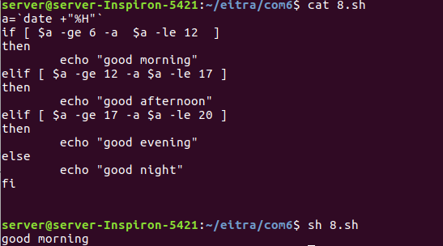

9 Write a script which reads a number in units of seconds and converts it to the units
hours:minutes:seconds and prints the result to standard output. Your script must prompt for re-input if a negative value is input. e.g. Enter number of seconds: 12345
Result: 12345 seconds in hours:minutes:seconds is 3:25:45
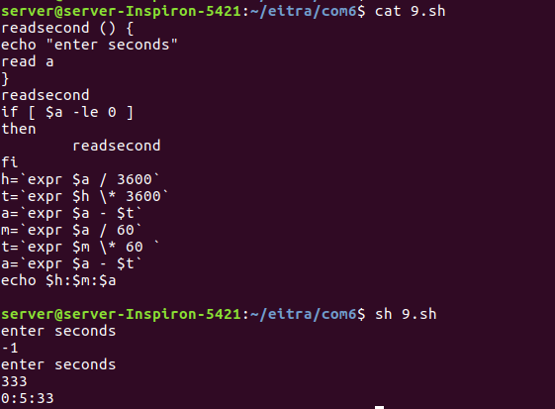

10 Write script to print given number in reverse order, for eg. If no is 123 it must print as 321.
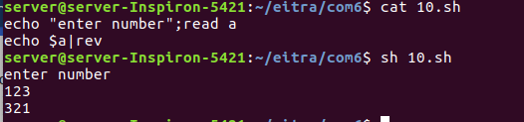

11 Write script to print given numbers sum of all digit, eg. If no is 123 it's sum of all digit will be 1+2+3 =6
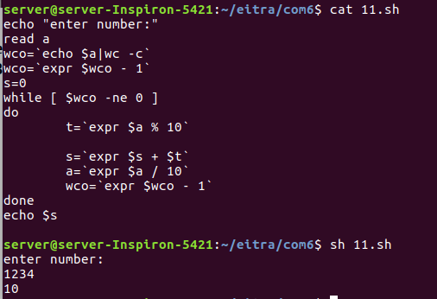

12 Write script to determine whether given file exist or not, file name is supplied as command line argument, also check for sufficient number of command line argument.
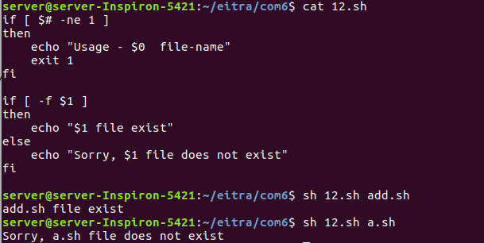
13 Write script to determine whether given command line argument ($1) contains "*" symbol or not, if $1 does not contains "*" symbol add it to $1, otherwise show message "Symbol is not required".
e.g. If we called this script Q12 then after giving ,
$ Q12 /bin
Here $1 is /bin, it should check whether "*" symbol is present or not if not it should print Required i.e. /bin/*, and if symbol present then Symbol is not required must be printed. Test your script as
$ Q12 /bin
$ Q12 /bin/*
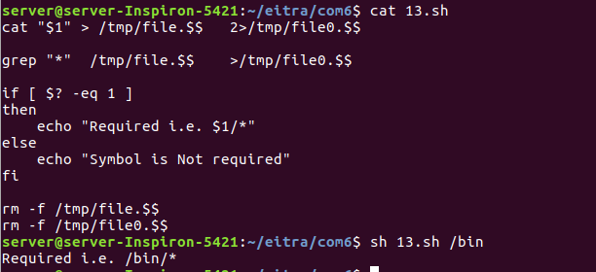

14 Write script to print contains of file from given line number to next given number of lines.
e.g. If we called this script as Q13 and run as $ Q13 5 5 myf ,
Here print contains of 'myf' file from line number 5 to next 5 line of that file.
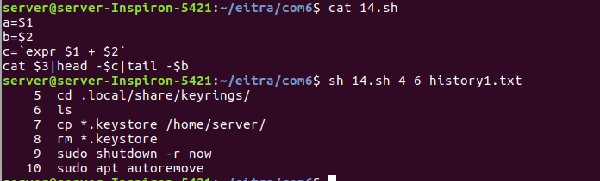
15 Write script to implement getopts statement, your script should understand following command line argument called this script Q14,
Q14 -c -d -m -e
Where options work as
-c clear the screen
-d show list of files in current working directory
-m start mc (midnight commander shell) , if installed
-e { editor } start this { editor } if installed
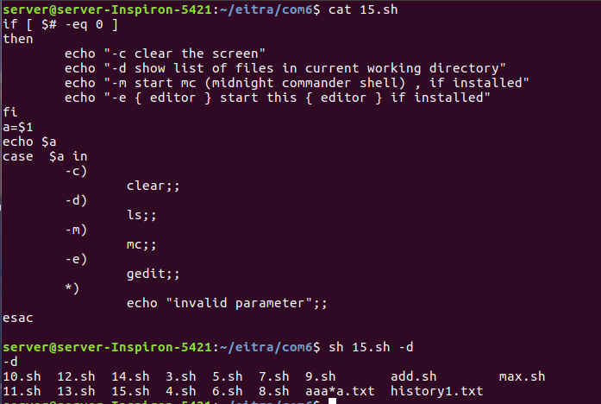
16 Write script called sayHello, put this script into your startup file called .bash_profile, the script should run as soon as you logon to system, and it print any one of the following message in infobox using dialog utility, if installed in your system, If dialog utility is not installed then use echo statement to print message
Good Morning
Good Afternoon
Good Evening , according to system time.
At login, most shells execute a login script, which you can use to execute your custom script. The login script the shell executes depends, of course, upon the shell:
- bash: .bash_profile, .bash_login, .profile (for backwards compabitibility)
- sh: .profile
- tcsh and csh: .login
- zsh: .zshrc

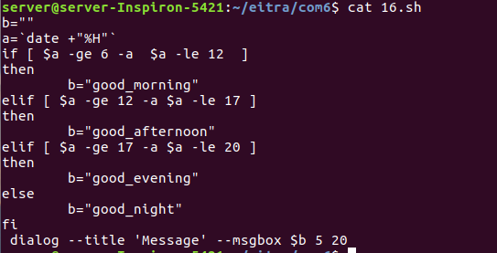

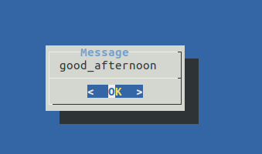

17 How to write script, that will print, Message "Hello World" , in Bold and Blink effect, and in different colors like red, brown etc using echo command.
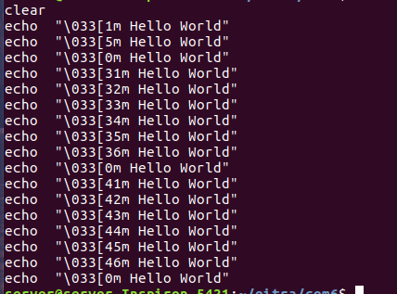

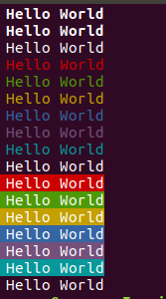

18 Write script to implement background process that will continually print current time in upper right corner of the screen , while user can do his/her normal job at $ prompt.
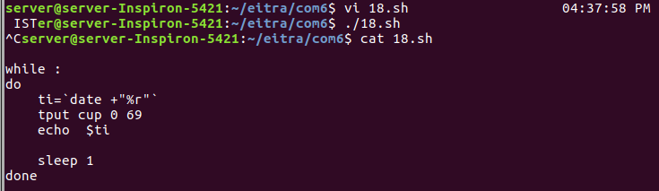
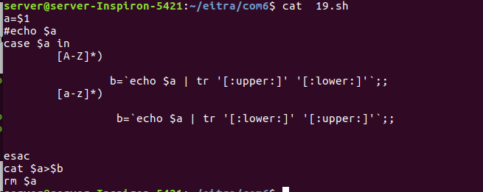
19 Write shell script to convert file names from UPPERCASE to lowercase file names or vice versa.

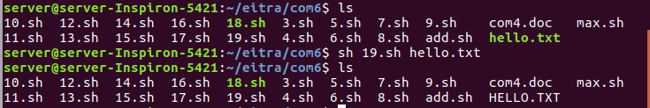

20 Write shell script to show various system configuration like
1) Currently logged user and his logname
2) Your current shell
3) Your home directory
4) Your operating system type
5) Your current path setting
6) Your current working directory
7) Show Currently logged number of users
8) About your os and version ,release number , kernel version
9) Show all available shells
10) Show mouse settings
11) Show computer cpu information like processor type, speed etc
12) Show memory information
13) Show hard disk information like size of hard-disk, cache memory, model etc
14) File system (Mounted)
